 | RIVER VALLEY HIGH SCHOOL  YEAR 6 PRELIMINARY EXAMINATION

H2 CHEMISTRY |  | 9647/03
Paper 3 Free Response
Suggested Answers

1 | (a) | Amount of MnO₂ = 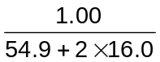  = 0.0115 mol  Amount of Cl₂ = 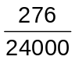  = 0.0115 mol  Therefore MnO₂ ≡ Cl₂ ≡ 2e⁻ (2Cl ⁻ → Cl₂ + 2e⁻)  Oxidation number of Mn in Mn-containing product = +4 − 2 = +2  MnO₂ + 4H⁺ + 2e⁻ → Mn²⁺ + 2H₂O  MnO₂(s) + 2HCl(aq) + 2H⁺(aq) → Mn²⁺(aq) + Cl₂(g) + 2H₂O(l)
 | (b) | (i) | I ⁻(s) + H₂SO₄(l) → HSO₄⁻(s) + HI(g)  8HI(g) + H₂SO₄(l) → H₂S(g) + 4I₂(g) + 4H₂O(l)
 |  | (ii) | Cl₂ + 2e⁻  2Cl ⁻ E = +1.36 V  I₂ + 2e⁻  2I ⁻ E = +0.54 V  E(Cl₂/Cl ⁻) is more positive than E(I₂/I ⁻), hence Cl ⁻ is less easily oxidised than I ⁻.
 | (c) | 2Br ⁻(aq) + Cl₂(g) → Br₂(aq) + 2Cl ⁻(aq)
 | (d) | F₂ + 2e⁻  2F ⁻ E(F₂/F ⁻) = +2.87 V  Fluorine is the strongest oxidising agent (and is the most reactive halogen).  Electrolysis (of molten sodium fluoride).
 | (e) | Cl₂: Reacts explosively in sunlight but slowly in the dark  Br₂: Reacts at above 200 °C over Pt catalyst  I₂: Reacts at 400 °C over Pt catalyst (to form an equilibrium mixture)  The reaction of H₂ with Cl₂ is more exothermic than with Br₂ which is in turn more exothermic than with I₂ as the H—Cl bond is stronger than the H—Br bond which is stronger than the H—I bond. Hence the reaction with Cl₂ requires the mildest conditions and the reaction with I₂ requires the harshest conditions.

 | (f) | To distinguish 4-methylbenzyl bromide from A:  - Add NaOH(aq) and heat, then add excess dilute HNO₃ followed by AgNO₃(aq). Cream ppt formed with 4-methylbenzyl bromide but not with A.  To distinguish 4-methylbenzyl bromide from B:  - Add AgNO₃(aq). White fumes and cream ppt formed immediately with B but not for 4-methylbenzyl bromide.
 | (g) | MgCl₂ forms a weakly acidic (or neutral solution) with pH = 6.5 (or 7).  MgCl₂(s) + 6H₂O(l) → [Mg(H₂O)₆]²⁺(aq) + 2Cl ⁻(aq) (for neutral solution)  [Mg(H₂O)₆]²⁺(aq) + H₂O(l)  [Mg(H₂O)₅(OH)]⁺(aq) + H₃O⁺(aq) (both equations for weakly acidic solution)  PCl₅ forms a strongly acidic solution with pH = 2.  PCl₅(s) + 4H₂O(l) → H₃PO₄(aq) + 5HCl(aq)
 | (state symbols not required for this whole question)

2 | (a) | (i) | S  O  O  O  Trigonal planar
 |  | (ii) | Both SO₂ and SO₃ have simple covalent/molecular structures. As SO₃ molecules have a larger number of electrons, more energy is required to overcome the stronger instantaneous dipole-induced dipole interactions between the non-polar SO₃ molecules than the weaker permanent dipole-permanent dipole interactions between the polar SO₂ molecules. Hence, SO₃ has a higher boiling point than SO₂.
 | (b) | (i) | The tertiary structure of a protein is the overall three-dimensional shape of a polypeptide, as stabilised by the side-chain interactions.
 |  | (ii) | 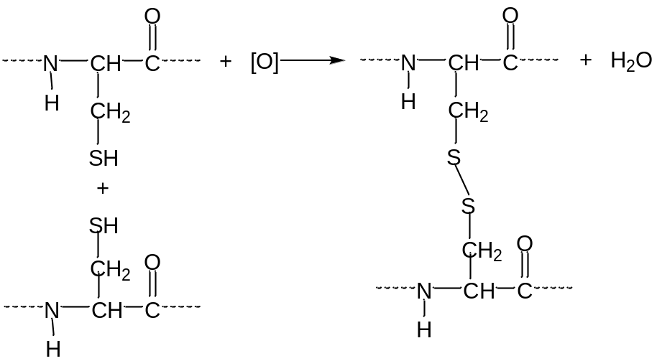
 |  | (iii) | Ionic interactions, hydrogen bonding and van der Waals’ forces.
 |  | (iv) | Heavy metal ions form ionic interactions with the −COO⁻ groups on the side chains and disrupt the ionic interactions in the tertiary structure. This brings about the formation of insoluble protein salts (i.e. precipitation of protein) and leads to denaturation.  Heavy metal ions have a high affinity for sulfur and disrupt the disulfide bridges in the tertiary structure, leading to denaturation.
 | (c) | (i) | The standard enthalpy change of combustion of mercaptopurine is the energy change when one mole of mercaptopurine is completely burnt in oxygen under standard conditions of 298 K and 1 atm.  C₅H₄N₄S(s) + 7O₂(g) → 5CO₂(g) + SO₂(g) + 2N₂(g) + 2H₂O(l)  (state symbols required)
 |  | (ii) | ΔH_{c} = [2E(N—H) + 2E(C—H) + 2E(C=N) + 6E(C—N) + E(C=C) + E(C=S) + E(C—C) + 7E(O=O)] – [10E(C=O) + 2E(S=O) + 2E(N≡N) + 4E(O—H)]  = [2(+390) + 2(+410) + 6(+305) + 2(+610) + (+610) + (+138) +(+350) + 7(+496)] – [10(+740) + 2(+128) + 2(+994) + 4(+460)]  = +9220 – (+11484)  = –2264 kJ mol⁻¹
 |  | (iii) | Heat absorbed by water = 100 × 4.18 × (87 – 25)  = 2.59 × 10⁴ J  Heat evolved by combustion = 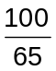 × 2.59 × 10⁴  = 3.98 × 10⁴ J  Amount of mercaptopurine = 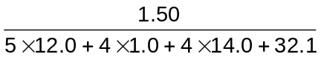  = 0.00986 mol  ΔH_{c} = −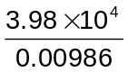  = −4.04 × 10⁶ J mol⁻¹  = −4040 kJ mol⁻¹
 |  | (iv) | The value for ΔH_{c} obtained from bond energies in (c)(ii) is not accurate as the bond energies quoted from the Data Booklet represent average bond energies derived from the full range of molecules that contain the particular bonds.  Mercaptopurine and H₂O are in the solid and liquid states respectively under standard conditions but the calculation in (c)(ii) makes use of bond energies which relate to breaking of covalent bonds in gaseous molecules. The enthalpy change of sublimation of mercaptopurine and enthalpy change of vapourisation of H₂O are not accounted for in the calculation of ΔH_{c}.

3 | (a) | X⁻ → X + e⁻
 | (b) | (i) | The reaction is autocatalytic as the Ag produced catalyses the reaction. The rate of reaction increases at first due to the formation of the Ag autocatalyst, then decreases as the reactants are used up.
 |  | (ii) | Z undergoes condensation with 2,4-DNPH ⇒ Z is a carbonyl compound / contains ketone or aldehyde functional group  1 molar equivalent of Z undergoes electrophilic addition with 2 molar equivalents of Br₂ ⇒ Z contains two alkene functional groups  Z undergoes oxidation with hot acidified KMnO₄(aq) to give two identical compounds ⇒ Z contains a plane of symmetry  Y is insoluble in water (due to large hydrophobic benzene ring) but can undergo acid-base reaction with NaOH(aq) ⇒ Y contains phenol or carboxylic acid group  Y does not undergo acid-carbonate reaction with Na₂CO₃ ⇒ Y is not a carboxylic acid, so Y contains phenol group  Y undergoes acid-metal reaction with Na ⇒ Y contains phenol group  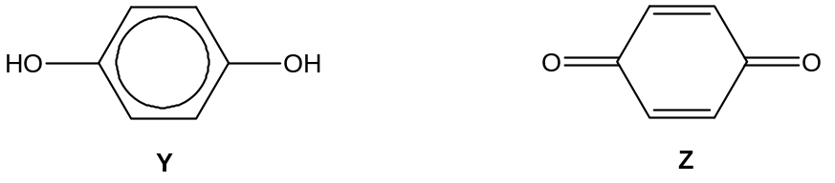
 | (c) | (i) | pH = pK_{a} + lg 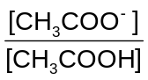 = −lg (1.8 × 10⁻⁵) + lg 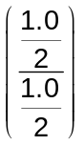  = 4.74

 |  | (ii) | CH₃COOH + OH⁻ → CH₃COO⁻ + H₂O  Each dip will remove 0.0500 mol of CH₃COOH and introduce 0.0500 mol of CH₃COO⁻.  Let number of dips be n.  Amount of CH₃COOH left = (1.0 × 1) − 0.0500n  = (1 − 0.05n) mol  Amount of CH₃COO⁻ in resultant solution = (1.0 × 1) + 0.0500n  = (1 + 0.05n) mol  pH = −lg (1.8 × 10⁻⁵) + lg 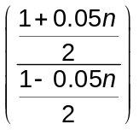 < 5  n < 5.71 ⇒ therefore maximum number of dips = 5
 | (d) | (i) | K_{sp} = [Ag⁺][X ⁻ ]
 |  | (ii) | Let solubility of AgX be x mol dm⁻³.  AgX(s)  Ag⁺(aq) + X ⁻(aq)  Equilibrium conc x x  1.0 × 10⁻¹⁰ = x²  x = 3.16 × 10⁻⁵ mol dm⁻³  Amount of Ag⁺(aq) in 1 dm³ of saturated solution = 3.16 × 10⁻⁵ mol
 |  | (iii) | From (d)(ii), AgX dissociates partially to give a small amount of Ag⁺ and X ⁻ ions in solution. As S₂O₃²⁻ is added, Ag⁺ forms a very stable [Ag(S₂O₃)₂]³⁻ complex with the S₂O₃²⁻ ions as seen from the large value of K_{c}(1) and [Ag⁺] in the solution decreases. As a result, the equilibrium position of the reaction for the dissociation of AgX shifts to the right, causing AgX to dissolve.
 | (e) | Carbon  Elimination / dehydration

4 | (a) | (i) | Reaction II: reduction;  conc. HCl and Sn, followed by NaOH(aq)  Reaction III: free radical substitution;  Cl₂, UV radiation
 |  | (ii) | Compound X: 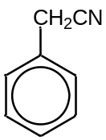  Reaction IV: alcoholic KCN, heat under reflux
 |  | (iii) | Reaction V: acidic hydrolysis;  dilute H₂SO₄ or dilute HCl, heat under reflux
 | (b) | 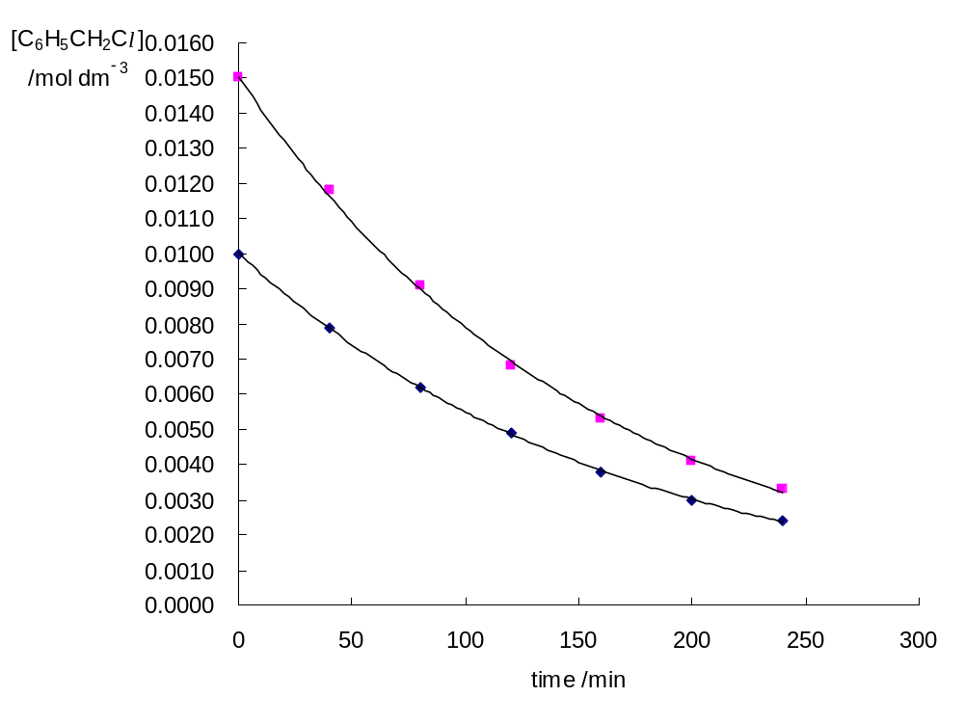  (i)  gradient₁  gradient₂  (t_{1/2})₁  (t_{1/2})₂  Experiment 1  Experiment 2
 |  | (ii) | As successive half-lives are the approximately the same ((t_{1/2})₁ ≈ (t_{1/2})₂), the reaction is 1st order with respect to C₆H₅CH₂Cl.  gradient₂ = 1.5 × gradient₁, this shows that when both [NaOH] and [C₆H₅CH₂Cl] are increased to 1.5 times, the initial rate also increased to 1.5 times.  As order of reaction with respect to C₆H₅CH₂Cl is 1, the rate of reaction is independent of [NaOH]. Hence, reaction is 0th order with respect to NaOH.
 |  | (iii) | Rate = k[C₆H₅CH₂Cl]  k = gradient ÷ [C₆H₅CH₂Cl]  = (value) min⁻¹  or k = 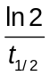

 |  | (iv) | Nucleophilic substitution  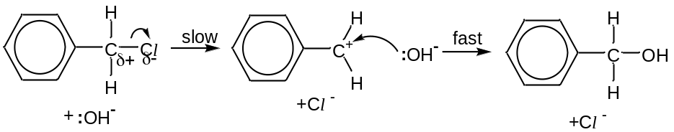
 |  | (v) | 4-chloromethylbenzene will not undergo hydrolysis reaction with NaOH(aq) as there is a partial double bond character in the C−Cl bond / and the C−Cl bond is stronger.

5 | (a) | A transition element is a d-block element which forms at least one stable (simple) ion with a partially-filled d-subshell.
 | (b) | Cu²⁺ contains partially filled 3d orbitals (electronic configuration 1s²2s²2p⁶3s²3p⁶3d⁹). In the presence of ligands in the hydrated ion, the 3d orbitals are split into 2 sets of non-degenerate orbitals (or orbitals with different energies). The difference in energy (ΔE) between the 2 sets of 3d orbitals is small and radiation from the visible region of the electromagnetic spectrum is absorbed when an electron moves from a lower energy d-orbital to a partially-filled d orbital of higher energy. The colour observed corresponds to the complement of the absorbed colours. Hence, the hydrated copper(II) ion is coloured.  Cu⁺ contains completely filled 3d orbitals (electronic configuration 1s²2s²2p⁶3s²3p⁶3d¹⁰) and d-d electronic transition cannot occur. Hence, Cu₂SO₄ is colourless.
 | (c) | White solid dissolves to give a blue solution and a pink/reddish brown solid.  Cu⁺ undergoes disproportionation to give Cu²⁺ and Cu.  Cu⁺ + e⁻  Cu E = +0.52 V  Cu²⁺ + e⁻  Cu⁺ E = +0.15 V  2Cu⁺ → Cu²⁺ + Cu or Cu₂SO₄ → CuSO₄ + Cu  E_{cell} = +0.52 − (+0.15) = +0.37 V > 0 V (energetically feasible)
 | (d) | Cu²⁺ + 2e⁻  Cu E = +0.34 V  VO₃⁻ + 4H⁺ + e⁻  VO²⁺ + 2H₂O E = +1.00 V  Cu(s) + 2VO₃⁻ (aq) + 8H⁺(aq) → Cu²⁺(aq) + 2VO²⁺(aq) + 4H₂O(l)  E_{cell} = +1.00 − (+0.34) = +0.66 V > 0 V (energetically feasible)  VO²⁺ + 2H⁺ + e⁻  V³⁺ + H₂O E = +0.34 V  Cu(s) + 2VO²⁺(aq) + 4H⁺(aq) → Cu²⁺(aq) + 2V³⁺(aq) + 2H₂O(l)  E_{cell} = +0.34 − (+0.34) = 0 V (in equilibrium)  A blue-green solution (of blue VO²⁺ and green V³⁺ in equilibrium) will be obtained.
 | (e) | (i) | Repulsion between the two negatively charged reactants causes the reaction to have a high activation energy.
 |  | (ii) | Cu²⁺(aq) acts as a homogeneous catalyst.
 |  | (iii) | The EDTA ligand forms a stable complex with Cu²⁺ and therefore removing the Cu²⁺ catalyst.
 | (f) | (i) | aliphatic aldehyde
 |  | (ii) | 2Cu²⁺(aq) + 2OH⁻(aq) + 2e⁻ → Cu₂O(s) + H₂O(l)
 | (g) | (i) | Blue solution turns brown (with black ppt) and cream ppt formed.  2Cu²⁺(aq) + 4I ⁻(aq) → 2CuI(s) + I₂(s/aq)
 |  | (ii) | Amount of S₂O₃²⁻ needed = 0.100 × 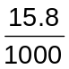  = 0.00158 mol  2S₂O₃²⁻ + I₂ → S₄O₆²⁻ + 2I ⁻ (2S₂O₃²⁻ ≡ I₂)  Amount of I₂ produced = 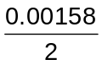  = 0.000790 mol  2Cu²⁺ ≡ I₂  Amount of Cu in sample = 2 × 0.000790  = 0.00158 mol  Mass of Cu in sample = 0.00158 × 63.5  = 0.100 g  % by mass of Cu in sample = 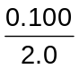 × 100%  = 5.00%
 | (state symbols not required for this whole question)

